A10: Advantages of using AI in Government and Public Sector
Assignment Title: Enhancing Government and Public Sector Services through
Artificial Intelligence (AI)
Student Name: Nestor Villalobos
Course Title: Artificial Intelligence Application
Instructor: Anna Devarakonda
Date: 04/09/2026

1. Introduction
Artificial Intelligence is reshaping the public sector by leveraging machine learning, NLP, and predictive analytics to turn massive datasets into actionable insights. While it enhances efficiency in areas like healthcare, disaster management, and fraud detection, its adoption requires a careful balance between improved service delivery and addressing ethical risks, such as privacy concerns and algorithmic bias.
The report focuses on these dynamics through a public health case study and a proposed governance framework.

2. Case Study Analysis: AI in Public Health – COVID-19 Response
2.1 Problem or Need Addressed
The COVID-19 pandemic required governments to respond rapidly to a global crisis.
Key challenges included:
- Predicting infection spread
- Allocating limited healthcare resources
- Informing public policy decisions
- Communicating effectively with citizens
Traditional systems lacked the speed and scalability required to process real-time global data.

2.2 AI Tools and Techniques Implemented
Governments and health organizations deployed:
- Machine Learning Models: Forecast infection trends
- Natural Language Processing (NLP): Analyze scientific literature and public communication
- Computer Vision: Monitor compliance (e.g., mask usage)
- Chatbots: Provide real-time health information
- Big Data Analytics: Integrate multiple data sources

2.3 Outcomes and Benefits Achieved
AI implementation led to:
- Faster and more accurate predictions
- Efficient allocation of medical resources
- Improved communication through automation
- Accelerated vaccine and drug research
- Data-driven policymaking

2.4 Challenges and Limitations
- Privacy concerns due to sensitive health data
- Data inconsistency affecting predictions
- Bias in AI models
- Unequal access to digital tools
- Limited transparency in AI decisions

2.5 Visual Representation: AI in COVID-19 Response
Figure 1: AI Workflow in Public Health Management
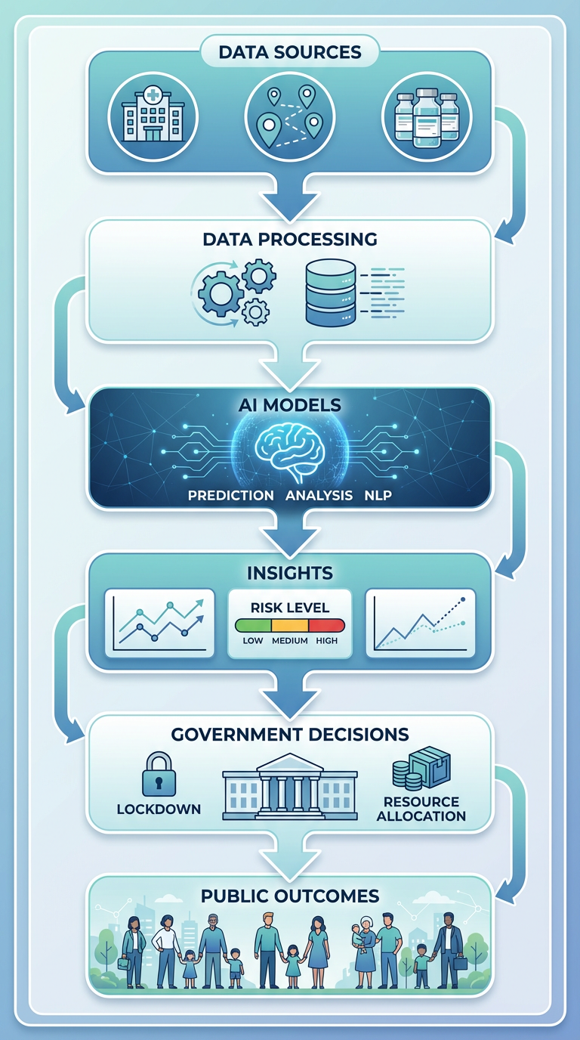

3. Innovative Proposal: AI-Driven Smart Governance Platform
3.1 Problem Statement
Governments face challenges in:
- Engaging citizens effectively
- Responding to public concerns
- Delivering personalized services
- Making informed policy decisions

3.2 Proposed Solution
An AI-Driven Smart Governance Platform that integrates citizen data, feedback, and predictive analytics.

3.3 System Architecture Diagram
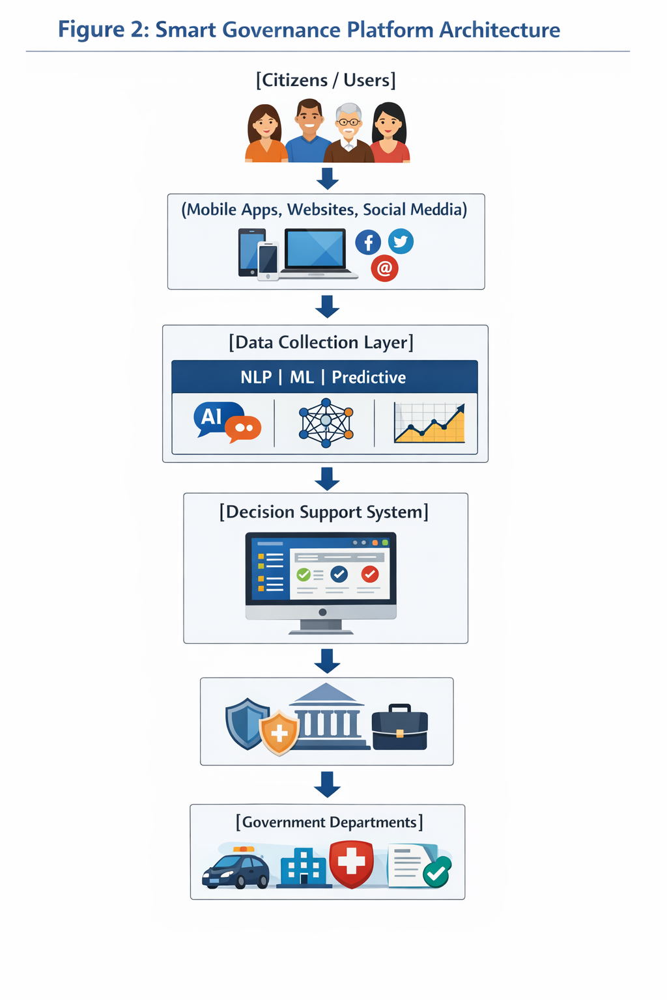

3.4 Expected Outcomes (Chart)
Table 1: Impact of AI on Public Services
Area | Without AI | With AI
Response Time | Slow | Real-time
Decision-Making | Reactive | Predictive
Citizen Engagement | Limited | High & Continuous
Cost Efficiency | High costs | Reduced costs
Service Personalization | Generic | Tailored services

3.5 Justification
This system improves governance by:
- Enhancing transparency
- Increasing efficiency
- Enabling proactive policymaking
- Improving citizen satisfaction

3.6 Potential Challenges
- Data security risks
- Ethical concerns
- Infrastructure costs
- Digital literacy gaps

3.7 Mitigation Strategies
- Strong cybersecurity frameworks
- Ethical AI guidelines
- Public-private partnerships
- Citizen training programs

4. Conclusion
AI can significantly improve public services, as shown during COVID-19 and in future platforms like Smart Governance systems. However, governments must handle ethical, technical, and social challenges carefully. When implemented responsibly, AI can make governance more efficient, transparent, and focused on citizens.
5. References (APA Format)
Organization for Economic Co-operation and Development (OECD). (2021). The use of artificial intelligence in the public sector. OECD Publishing.
World Health Organization. (2020). Artificial intelligence for COVID-19 response. WHO Press.
McKinsey & Company. (2021). The state of AI in government.
World Bank. (2022). Artificial intelligence for development: Opportunities and challenges.
Topol, E. (2019). Deep medicine: How artificial intelligence can make healthcare human again. Basic Books.

